Statistics for Data Science and Machine Learning
Statistics is a powerful mathematical field. I’m saying “powerful” because it helps us to infer a population outcome from sample data. As it can infer population outcome, it can also be used for the big picture (like overall impact, future forecast, etc.). Statistics is not just a combination of some merely isolated topics. Moreover, Statistics discovers new semantics within these topics, which sometimes paves the way for new opportunities. Statistics needs everywhere in our day-to-day life.

Table of Contents
- Statistics at a Glance
- Population and Sample
- Variable and Level of Measurement
- Central Tendency (Mean, Median and Mode)
- Percentile, Quartile and IQR
- Frequency Distribution and Visualization
- Measure of Dispersion (Range, Variance, Standard Deviation, etc.)
- Covariance and Correlation Coefficient
- Normalization
- Probability
- Probability Distribution (Uniform, Binomial, Poisson, Normal and Student’s t distribution)
- Central Limit Theorem
- Point Estimator and Estimate
- Standard Error
- Confidence Interval and Level
- Significance level
- Hypothesis Testing
- Analysis of Variance (ANOVA)
- Chi-Square Test

Statistics at a Glance
Statistics combines some techniques for drawing a reliable conclusion about a large group (population) by experimenting on a small group (sample) and summarizing the dataset. It is not a formal definition; it’s my realization while working with statistics.
Statistics is the discipline that concerns the collection, organization, analysis, interpretation, and presentation of data.
There are two categories of statistics.
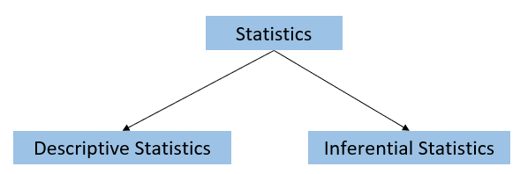
- Descriptive statistics summarizes/describes the population or sample dataset. It covers the topics — types of data, variables, data representation, frequency distribution, central tendency, percentile and quartile, covariance, correlation, etc.
- Inferential statistics is part of statistics that finds reliable inferences of population data from sample data. It covers — probability distribution, Central Limit Theorem, Point Estimator and Estimate, Standard Error, Confidence Interval and Level, Level of Significance, Hypothesis Testing, Analysis of Variance (ANOVA), Chi-Square Test, etc.

Population and Sample
The population consists of all the members of an experiment, whereas sample is a selected group of members from the population which represents that population.
For example, we want to know university students’ average CGPA. Here, the experimental area covers all the students. So, the population will be all the students of that university. If we pick some students to calculate the average CGPA, these students will be the sample.

Variable and Level of Measurement
Simply variable is something which can vary (hold multiple values). It is nothing but the features of a dataset. There are different types of data as different features exist in the real world. We must know the measurement level to understand how we deal with the data.

Central Tendency
Central tendency is a way to find out the tendency of majority values. In statistics, mean, median, and mode are used to know it.
- Mean
The concept of “mean” is straightforward. We get the mean value by dividing the summation by the number of values (n).
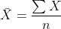

- Median
The Median is another way to know the central tendency. To get the median value, we need to sort the values in ascending order and pick up the middle value, it varies with the even and odd number of values.
For example, 12, 13, 10, 15, and 7 are the series of values. Firstly, we need to sort out the values. After sorting, the sequence will be 7, 10, 12, 13, and 15. The total number of values is 5, which is an odd number. So, we will use the following formula —

In our case, 12 is the median.
Another example is that some values are 12, 13, 10, 15, 7, and 9. After sorting, we get 7, 9, 10, 12, 13, and 15. This time, the number of values is 6, and it’s even. So, we won’t get the middle value with the above formula. Because (6+1)/2= 3.5 is not a whole number. Now, we need to sum up the 3rd and 4th values. And their mean is the median value, 22/2 = 11.
- Mode
The mode works on categorical data, and it is the highest frequency of a dataset. Suppose you have some data containing the quality of a product like [‘good’, ‘bad’, ‘normal’, ‘good’, ‘good’]. Here, good has the highest frequency. So, it is the mode for our data.
When to use which central tendency?
In the case of nominal data, we use mode. For ordinal data, the median is recommended. Mean is widely used to find the central tendency of ratioed / interval variables. But the mean is not always the right choice to determine the central tendency because if the dataset contains outliers, the mean will be very high or low. In that case, the median is more robust than the mean. We will use the median if the median is greater or less than the mean. Otherwise, mean is the best choice.

Percentile, Quartile and IQR
- Percentile
A percentile is a measure used in statistics indicating the value below which a given percentage of observations in a group of observations fall. For example, the 20th percentile is the value (or score) below which 20% of the observations may be found.
- Quartile
In the percentile, the entire values are divided into 100 different parts. The quartile divides the values into four equal parts, and each part holds 25%. The main quartiles are First Quartile (Q1), Second Quartile (Q2), Third Quartile (Q3) and Fourth Quartile (Q4).
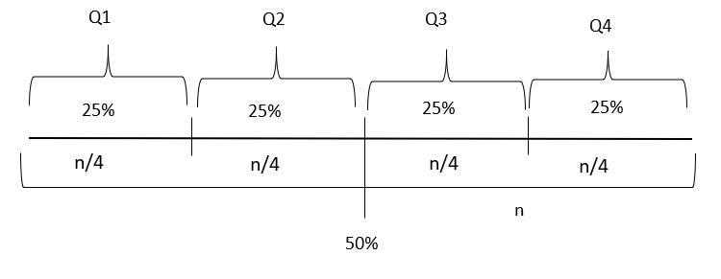
- IQR (Inter Quartile Ratio)
IQR is the range between Q1 and Q3. So, IQR = Q1 — Q3 .
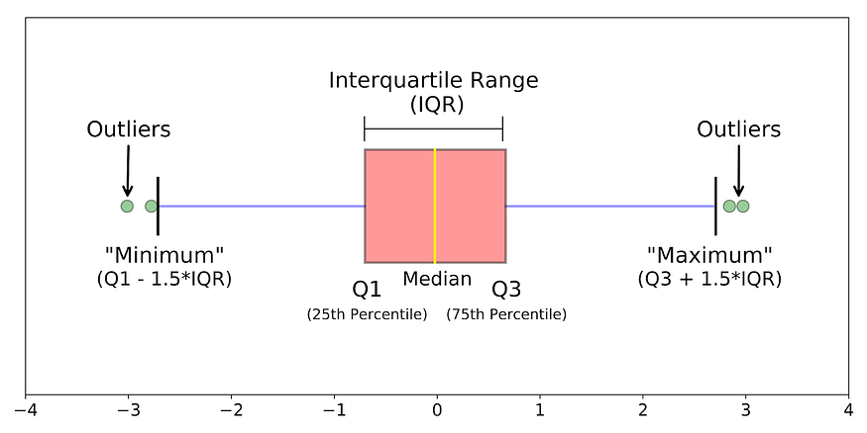
We can also find out the outlier with IQR by defining a minimum (Q1 -1.5*IQR, also known as lower fence) and maximum (Q3 + 1.5*IQR, also known as upper fence) boundary value. Outside the minimum and maximum values are considered outliers.
Boxplot shows all the Quartiles and upper and lower fences.
Quartiles are statistical measures that divide a dataset into four equal parts, each representing 25% of the data. They are used to analyse the distribution and variability of a dataset. Quartiles provide insights into the spread of data and help identify outliers or extreme values.
There are three quartiles: the first quartile (Q1), the second quartile (Q2), and the third quartile (Q3).
First Quartile (Q1): Q1 represents the 25th percentile of the data. It separates the lowest 25% of the dataset from the upper 75%. In other words, 25% of the data points are below Q1.
Second Quartile (Q2): Q2 is also known as the median. It represents the middle value of the dataset when it is arranged in ascending or descending order. 50% of the data points are below Q2, and the remaining 50% are above Q2.
Third Quartile (Q3): Q3 represents the 75th percentile of the data. It separates the lowest 75% of the dataset from the upper 25%. Thus, 75% of the data points are below Q3.
The interquartile range (IQR) is another important component associated with quartiles. It is calculated as the difference between Q3 and Q1 (IQR = Q3 - Q1). The IQR provides a measure of the spread of the middle 50% of the data. It is commonly used to identify outliers, which are values that fall below Q1 - 1.5 * IQR or above Q3 + 1.5 * IQR.
Quartiles are valuable tools in descriptive statistics and data analysis, providing insights into the central tendency and variability of a dataset. They are commonly used in box plots, where the data points within each quartile are visualized along with outliers and the median.
A quantile plot, also known as a quantile-quantile plot or Q-Q plot, is a graphical tool used to assess if a dataset follows a particular theoretical distribution. It compares the observed quantiles of the dataset against the quantiles expected from the chosen theoretical distribution.
The steps to create a quantile plot are as follows:
Sort the data in ascending order.
Calculate the quantiles for the sorted data points. These are the values that divide the data into equal-sized intervals. Common quantiles include quartiles (25th, 50th, and 75th percentiles) and deciles (10th, 20th, ..., 90th percentiles).
Determine the corresponding quantiles from the chosen theoretical distribution. This can be achieved by calculating the inverse cumulative distribution function (CDF) of the distribution for the desired quantile levels.
Plot the observed quantiles against the expected quantiles on a scatter plot.
If the data follows the chosen theoretical distribution, the points on the plot should roughly align along a straight line. Deviations from a straight line may indicate departures from the assumed distribution.
The quantile plot is a visual tool to assess how well a dataset fits a theoretical distribution. It helps identify deviations such as skewness, heavy tails, or outliers. If the points on the plot deviate significantly from a straight line, it suggests that the data may not conform to the assumed distribution.
Quantile plots are commonly used in exploratory data analysis and model diagnostics. They allow researchers and analysts to compare observed data against theoretical distributions, assess goodness of fit, and guide the selection of appropriate statistical models.

Skewness measures the degree of asymmetry of a distribution while Kurtosis measures the degree of peakedness of a distribution.
While analyzing the data or doing Exploratory Data Analysis, we always look for skewness and kurtosis. Both measures give information about the shape of the distribution, but they capture the different aspects of the data. Skewness measures the degree of asymmetry in the distribution, while kurtosis measures the degree of peakedness or flatness.

What is the Difference Between Skewness and Kurtosis?
Parameter | Skewness | Kurtosis
Definition | It measures the degree of asymmetry of a distribution. | It measures the degree of peakedness of a distribution.
Calculation | It is the third moment of distribution. | It is the fourth moment of distribution.
Range of Values | Values range from -infinity to +infinity | Values range from -infinity to +infinity
Interpretation of Values | Negative Skewness: Indicates a long tail on the left-hand side.  Zero Skewness: Indicates Perfect Symmetry.  Positive Skewness: Indicates a long tail on the right side. | Platykurtic: It indicates a flatter peak than the normal distribution. It is also referred to as Negative Kurtosis.  Zero Kurtosis indicates perfect normality.  Leptokurtic: It indicates a sharper peak than the normal distribution. It is also referred to as Positive Kurtosis.
Impact on Distribution | Skewness can affect the centre of the distribution. Asymmetrical distribution has a larger impact on the mean than the median. | Kurtosis can affect the tail of the distribution. High kurtosis distribution has more extreme values ad can lead to larger standard errors.
Example Distribution | Income, wealth, and stock returns are often positively skewed. Distribution, like retirement age, can be seen as negatively skewed. | Exam scores, IQ scores, and reaction time are often leptokurtic. Platykurtic distributions include income, height, and weight.

What is Skewness?
Skewness defines the shape of the distribution. Usually, we get a lot of asymmetric distributions, and these distributions have unevenly spread data. There are two types of skewness – positive or right-skewed and negative or left-skewed.
Positive skewness is when the distribution takes place so that we get a long tail towards the right side of the graph. This is called a right-skewed graph,
In this distribution, the mean is greater than the median, which is in turn, greater than the mode. That is, we get mean > median > mode.
Negative skewness is when the distribution takes place so that we get a long tail towards the left side of the graph. This is called a left-skewed graph.
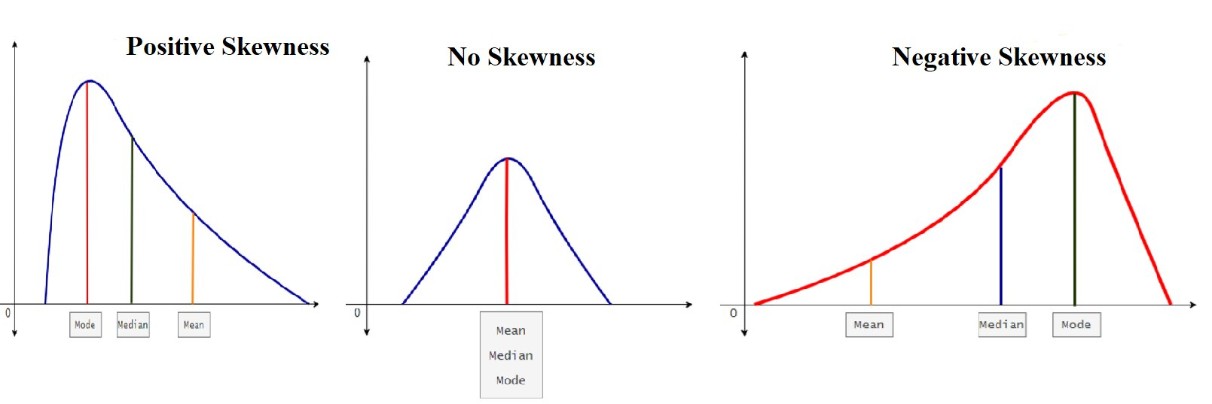

What is Kurtosis?
Kurtosis is a statistical measure that describes the degree of peakedness or flatness of a distribution. It measures the shape of the distribution, specifically the height and sharpness of the central peak, relative to that of normal distribution. It is the fourth moment of statistics.
The term “Kurtosis” comes from the Greek word “Kurtos”, which means curved.
Kurtosis is useful to identify the potential outliers in a dataset, as distributions with high kurtosis have more extreme values than normal distributions.
There are three types of Kurtosis: Mesokurtic, Leptokurtic, and Platykurtic.

Types of Kurtosis:
Mesokurtic: This is a type of distribution in which there is symmetry. This means that both the extreme ends of the graph are similar. This is the same as the normal distribution.
Leptokurtic: This distribution has a greater kurtosis than the mesokurtic, which has longer tails. This indicates that a more significant percentage of data is present near the tail, which causes the tail to get longer.
Platykurtic: This distribution has lower kurtosis than the mesokurtic. That is it has shorter tails. This means there is fewer data in the tail portion, which makes the tail flatter.
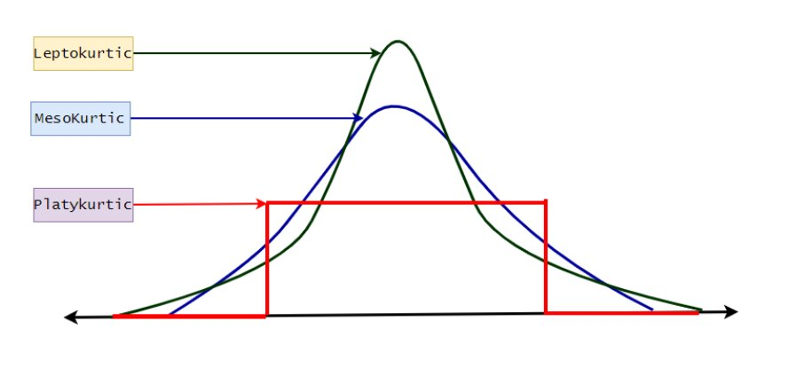

Key Differences Between Skewness and Kurtosis
- Skewness measures the degree of asymmetry of the distribution, while Kurtosis measures the degree of peakedness and flatness of a distribution.
- Skewness is the third measure of moments, while kurtosis is the fourth measure of moments.
- The value of both Skewness and Kurtosis ranges from -infinity to +infinity.
- Both zero skewness and zero kurtosis represent perfect symmetry and perfect normality.
- Skewness can affect the center of the distribution, while kurtosis can affect the distribution’s tails.
- Both Skewness and Kurtosis describe the shape of distributions.

In a skewed distribution, the mean, median, and mode may behave differently based on the direction and degree of skewness. There are two main types of skewed distributions:

1. **Positively Skewed (Right Skewed) Distribution:**

- **Mean:** The mean is typically greater than the median in a positively skewed distribution because the long tail on the right (higher values) pulls the mean in that direction.

- **Median:** The median is less than the mean and is usually closer to the first quartile (Q1). It is less affected by extreme values in the right tail.

- **Mode:** The mode is the value with the highest frequency. In a positively skewed distribution, the mode is typically lower than the median and mean.

![Positively Skewed Distribution](https://upload.wikimedia.org/wikipedia/commons/thumb/f/f8/Negative_and_positive_skew_diagrams_%28English%29.svg/500px-Negative_and_positive_skew_diagrams_%28English%29.svg.png)

2. **Negatively Skewed (Left Skewed) Distribution:**

- **Mean:** The mean is typically less than the median in a negatively skewed distribution because the long tail on the left (lower values) pulls the mean in that direction.

- **Median:** The median is greater than the mean and is usually closer to the third quartile (Q3). It is less affected by extreme values in the left tail.

- **Mode:** The mode is the value with the highest frequency. In a negatively skewed distribution, the mode is typically higher than the median and mean.

![Negatively Skewed Distribution](https://upload.wikimedia.org/wikipedia/commons/thumb/f/f8/Negative_and_positive_skew_diagrams_%28English%29.svg/500px-Negative_and_positive_skew_diagrams_%28English%29.svg.png)

**Summary:**

- In a skewed distribution, the mean is more sensitive to extreme values in the tail compared to the median.

- The median is less affected by outliers and is a more robust measure of central tendency in skewed distributions.

- The mode may provide insights into the peak or cluster of values, but its behavior depends on the shape of the distribution.

When analyzing data, it's essential to consider the skewness and choose central tendency measures accordingly. If the distribution is highly skewed, the median may be a more representative measure of the center.

Frequency Distribution and Visualization
Frequency is the measure of the occurrence of an event in a dataset.

Measure of Dispersion
The concept Measure of Dispersion indicates how spread the values are! Range, Variance, Standard Deviation. etc., are some of the techniques to find dispersion.
- Range
The range is the interval of maximum and minimum values. For example, we have some sample data 12, 14, 20, 40, 99, and 100. The range will be (100–12) = 88.
- Variance
Variance measures the difference between each value of a dataset from the mean value. Variance measures how far each number in the set is from the mean (average), and thus from every other number in the set.

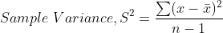
Here, x̄ is the sample mean and n is the number of values.

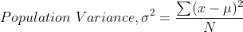
μ is the population mean and N is the number of population values.
- Standard Deviation
Standard Deviation is the square root of variance.

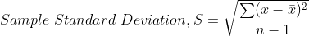
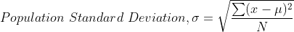

Covariance and Correlation
- Covariance
Covariance is a way to compare the variance between two numerical variables. The following formula is used to calculate it.
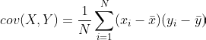
Here, x and y represent two variables. N is the number of the population.
- Correlation (Pearson Correlation)
It finds the linear relationship between two numerical variables.

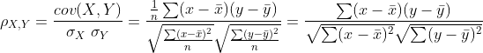
The correlation value fluctuates between -1 to +1. -1 indicates an entirely negative relationship, whereas +1 indicates a completely positive relationship between the variables. And 0 means no relationship.
The Pearson correlation coefficient, also known as Pearson's correlation or simply correlation, is a measure of the linear relationship between two variables. It quantifies the strength and direction of the relationship between two continuous variables.
The Pearson correlation coefficient is denoted by the symbol "r" and takes values between -1 and +1. The value of "r" indicates the degree of association between the variables:
If "r" is close to +1, it indicates a strong positive correlation, meaning that as one variable increases, the other variable tends to increase as well.
If "r" is close to -1, it indicates a strong negative correlation, meaning that as one variable increases, the other variable tends to decrease.
If "r" is close to 0, it indicates a weak or no correlation, meaning that there is little or no linear relationship between the variables.
The formula to calculate the Pearson correlation coefficient between two variables, X and Y, based on a set of paired observations (xᵢ, yᵢ), is:
r = (Σ((xᵢ - X̄)(yᵢ - Ȳ))) / (√(Σ((xᵢ - X̄)²) * Σ((yᵢ - Ȳ)²)))
where:
X̄ is the mean of X,
Ȳ is the mean of Y,
(xᵢ, yᵢ) are the individual data points, and
Σ represents summation (summing over all data points).
The Pearson correlation coefficient is widely used in statistics, research, and data analysis to assess the relationship between variables, identify patterns, and make predictions. It provides valuable insights into the strength and direction of linear associations between variables.
Introduction:
In the realm of data analysis, the quest to unveil patterns and relationships within datasets often starts with the exploration of correlations between variables. One of the fundamental tools for quantifying these relationships is Pearson's Correlation Coefficient. Widely employed in the domain of linear regression, this coefficient serves as a robust measure of the strength and direction of associations between continuous variables.
Table of Contents:
1. **What is Pearson’s Correlation Coefficient?**
2. **Example of Pearson’s Correlation Coefficient**
3. **Values of Pearson’s Correlation**
4. **Assumptions for a Pearson Correlation**
5. **Frequently Asked Questions**
### What is Pearson’s Correlation Coefficient?
Pearson’s Correlation Coefficient, denoted as 'r', is a statistical metric measuring the strength and direction of a linear relationship between two continuous variables. Ranging from -1 to 1, 'r' provides valuable insights into the nature of associations, guiding data analysts in understanding the connections within their datasets.
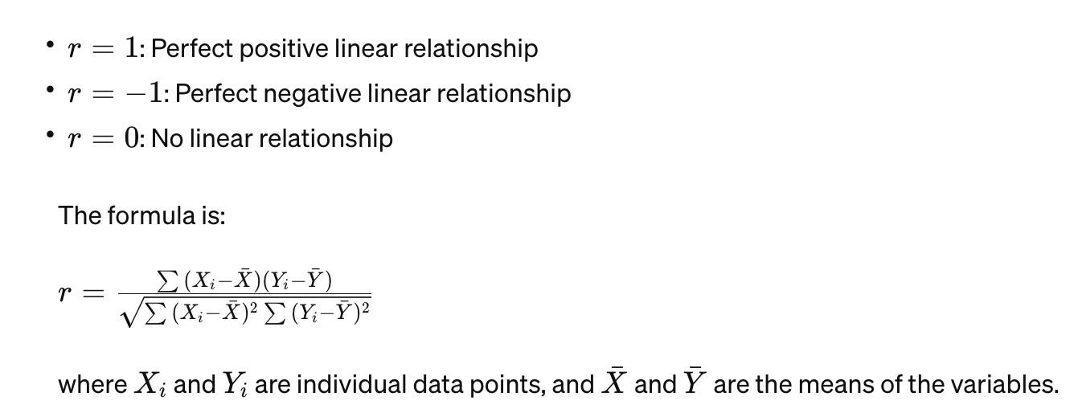
### Example of Pearson’s Correlation Coefficient
Consider a scenario where we aim to predict car prices based on various attributes such as car length, curb weight, and horsepower. Using Python, we can employ Pearson's Correlation Coefficient to discern relationships between these variables and the car price. Positive correlations indicate that as certain attributes increase, the car price tends to increase, while a lack of correlation suggests independence.
### Values of Pearson’s Correlation
The 'r' value ranges from -1 to 1, with 0 signifying no relation between variables. Positive 'r' values indicate a positive relationship, where an increase in one variable corresponds to an increase in the other. Conversely, negative 'r' values denote a negative relationship.
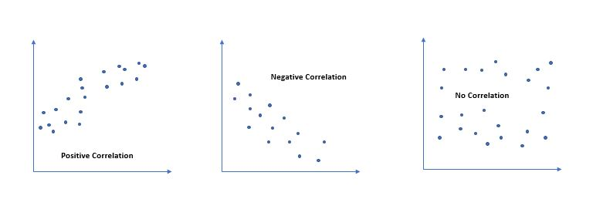
### Assumptions for a Pearson Correlation
For meaningful statistical inferences, data should be from random or representative samples. Both variables must be continuous and adhere to a normal distribution. Homoscedasticity, ensuring similar variance around the line of best fit, is crucial. Extreme outliers can impact the correlation coefficient, emphasizing the need for a careful examination of data.
### Conclusion
Pearson’s Correlation Coefficient is an indispensable tool for those venturing into statistics or data analysis. This guide has demystified the calculation and interpretation of 'r', providing insights into the strength and direction of linear relationships between variables. Armed with this knowledge, beginners can make informed decisions about data relationships. Pearson’s Correlation Coefficient opens the gateway to quantitative analysis, allowing for a deeper exploration and understanding of data patterns. Embrace the power of correlation to unravel meaningful insights from your datasets.

Normalization
Normalization is the process of converting the data into similar scale and it is one of the key parts of data pre-processing.
Normalization is a preprocessing technique used in machine learning to scale and transform features or variables to a common range. It ensures that different features have similar scales, preventing one feature from dominating the learning process over others.
Here are some reasons why normalization is done in machine learning:

Handling different scales: Features in a dataset often have different scales and ranges. For example, one feature may range from 0 to 100, while another feature may range from 0 to 100,000. When the features are not on the same scale, it can negatively impact the performance of certain machine learning algorithms, such as those based on distance or gradient descent. Normalization brings all features to a similar scale, preventing features with larger magnitudes from dominating the learning process.

Gradient descent convergence: Many optimization algorithms used in machine learning, such as gradient descent, converge faster on normalized data. When features have significantly different scales, the optimization process can become slower and less efficient. Normalization ensures that the optimization algorithm can converge more quickly, leading to faster training and better model performance.

Regularization and penalization: Regularization techniques, such as L1 or L2 regularization, are commonly used to prevent overfitting in machine learning models. These techniques introduce penalty terms that depend on the magnitude of the model weights. When features have different scales, the regularization may be dominated by features with larger values. Normalization helps to balance the regularization across all features, ensuring that no single feature has undue influence on the regularization process.

Distance-based algorithms: Machine learning algorithms that rely on distance calculations, such as k-nearest neighbors (KNN) or clustering algorithms, are sensitive to the scale of features. Features with larger scales can contribute more to the distance calculation, potentially overshadowing other features. Normalizing the features ensures that the distance calculations are not biased by the scale and enables fair comparisons between different features.

Interpretability and model understanding: Normalization can enhance the interpretability and understanding of the model. When features are on the same scale, it becomes easier to compare their coefficients or importance values. This helps in determining the relative contributions of different features to the model's predictions.

It's important to note that not all machine learning algorithms require normalization. Some algorithms, such as decision trees or random forests, are not affected by the scale of features. However, normalization is still beneficial for many other algorithms, especially those sensitive to feature scales or that rely on optimization techniques.

Common normalization techniques include min-max scaling (rescaling features to a specific range, typically between 0 and 1) and standardization (transforming features to have zero mean and unit variance). The choice of normalization technique depends on the specific requirements and characteristics of the data and the machine learning algorithm being used.
Normalization is performed in machine learning to handle different feature scales, improve convergence of optimization algorithms, balance regularization, enable fair distance-based comparisons, and enhance model interpretability and understanding.
There are several types of normalization techniques commonly used in machine learning:
Min-Max Normalization (also known as Rescaling):
Formula: x_scaled = (x - min(x)) / (max(x) - min(x))
Scales the data to a fixed range, usually between 0 and 1.
Z-Score Normalization (Standardization):
Formula: x_scaled = (x - mean(x)) / std(x)
Transforms the data to have zero mean and unit variance.
This method assumes the data follows a Gaussian distribution.
Decimal Scaling:
Formula: x_scaled = x / 10^k, where k is the smallest integer such that max(|x_scaled|) < 1.
Scales the data by shifting the decimal point, making the range of values between -1 and 1.
Log Transformation:
Formula: x_scaled = log(x)
Applies a logarithmic function to the data, which compresses the range of values.
Useful for handling skewed distributions or data with exponential growth.
Unit Vector Normalization:
Formula: x_scaled = x / ||x||
Scales the data such that each feature vector has a length of 1, turning it into a unit vector.
Commonly used for text classification and clustering algorithms.
The choice of normalization technique depends on the characteristics of the data and the specific requirements of the machine learning algorithm being used. It's important to understand the data and consider the implications of each normalization method to ensure optimal model performance.
Standard Scalar and Robust Scalar are two popular normalization techniques used in machine learning. Here's an explanation of each technique:
Standard Scalar (Standardization):
Standard Scalar, also known as Z-score normalization or standardization, transforms the data to have zero mean and unit variance.
It subtracts the mean from each feature and divides it by the standard deviation.
Formula: x_scaled = (x - mean(x)) / std(x)
Standard Scalar assumes that the data follows a Gaussian distribution.
It works well when the data is normally distributed or when the algorithm assumes zero-mean, unit-variance inputs.
Robust Scalar:
Robust Scalar is a normalization technique that is more resistant to outliers compared to Standard Scalar.
It scales the data using the interquartile range (IQR) and median.
Formula: x_scaled = (x - median(x)) / IQR(x)
It subtracts the median from each feature and divides it by the IQR.
Robust Scalar is effective when the data contains outliers or is not normally distributed.
It preserves the relative distances between data points and is less influenced by extreme values.
Both Standard Scalar and Robust Scalar are useful for normalizing features in machine learning. The choice between them depends on the characteristics of the data, the presence of outliers, and the assumptions of the learning algorithm. Standard Scalar is commonly used when the data follows a normal distribution, while Robust Scalar is preferred when the data contains outliers or is skewed.

Probability
Probability is a mathematical technique by which we can predict the probable outcome of an event.

Probability Distribution
The probability distribution is the distribution of all the probabilities of an event. There are two types of the probability distribution.
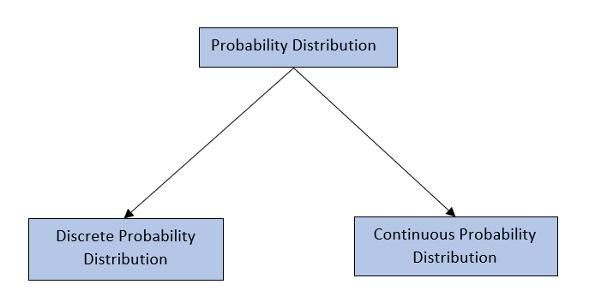
- Discrete Probability Distribution
The discrete probability distribution is the probability distribution of discrete values. For example, the probability of rolling a die. We find a specific outcome for each role, and it’s obvious a discrete value.
Uniform distribution, Binominal distribution, Poisson distribution, etc., are some of the main discrete probability distributions.
- Continuous Probability Distribution
The continuous probability distribution is the probability distribution of continuous value. For example, the probability of being age 24 of a sample group. As age 24 is a continuous value, we need to use continuous probability distribution.
Normal distribution, Student’s t distribution, etc., are some of the continuous probability distributions.
- Discrete Uniform Distribution
In uniform distribution, all the values of specific outcomes are equal. For example, rolling dice has 6 individual outcomes = {1,2,3,4,5,6}. If it is uniformly distributed, each probability value is 0.16667.
- Binomial Distribution
The name “Binomial” suggests two mutually exclusive outcomes of trials. For instance, head or tail, good or bad, pass or fail, etc.
For Binominal distribution, a trial must satisfy the criteria of the Bernoulli Trial.
The Bernoulli trial must have two independent outcomes like, high or low. The probability of success must be constant.
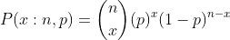
Here, n is the number of trials, p is the probability of success, and the number of successes x.
Binomial distribution finds the number of successes out of a specific number of trials.
Poisson distribution determines the number of successes within a unit of time interval.
For example, in a shop 8 customers arrive between 12 pm to 1 pm. With the help of Poisson distribution, we can find out the probability of arriving 3 people between 12 pm to 1 pm. Poisson distribution can be explained with the following formula.

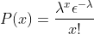
Where x is the number of successes, λ is the number of occurrences per unit of time. ε is the Euler number (2.71828…). For the above problem, x=3, λ=8/1=8.

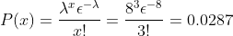
Red bar shows the probability of arriving 3 customers between 12pm to 1pm.
- Normal Distribution
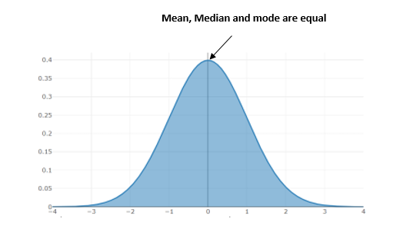
(Normal Distribution Graph)
The continuous probability distribution is applicable to continuous variables. The normal distribution is one of the widely used continuous probability distributions. Many real-life problems can be solved/described with normal distribution. Suppose we consider a sample age of 70 students. The age ranges from 18 to 25 years. It will be normally distributed if the mean, mode, and median are equal in that sample.
In case of normal distribution, the probability of the left and right parts being equally distributed means it is symmetrical. Total probability equal to 1. The distribution follows the following equation.
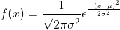
Here, σ is the standard deviation and μ is the mean.
Normal distribution will be a standard normal distribution when the standard deviation is 1, and the mean value is 0. Below is an example of the standard normal distribution with python.
- Student’s t distribution
William Sealy Gossett proposed the distribution. As there is a restriction in his working place to publish research articles with the original name, he used his pseudonym, “Student.” The distribution was proposed to find out the best sample from a small sample.
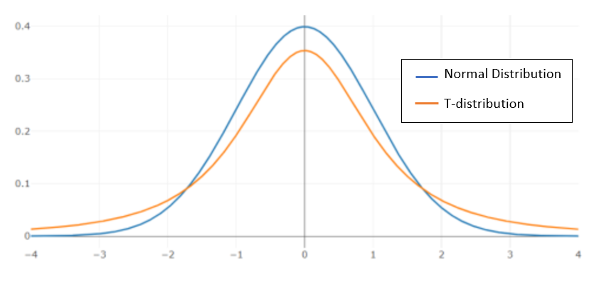
(Student’s T-distribution)
The image shows the comparison of two distributions. Student’s T-distribution has a fatter a tail than the normal distribution. Python implementation of student’s t distribution.
The Student's t-distribution, also known as the t-distribution, is a probability distribution that arises in statistical inference. It is used when working with small sample sizes or when the population standard deviation is unknown.
The t-distribution is similar in shape to the standard normal distribution (bell-shaped), but it has heavier tails. The shape of the distribution depends on the degrees of freedom (df), which determine the sample size.
The probability density function (PDF) of the t-distribution is given by the formula:
f(x) = [ Γ((df + 1) / 2) / (sqrt(df * π) * Γ(df / 2)) ] * [1 + (x^2 / df)]^(-((df + 1) / 2))
where:
x is the random variable
df is the degrees of freedom
Γ() is the gamma function
The mean of the t-distribution is 0 when the degrees of freedom are greater than 1. When the degrees of freedom are 1, the mean is undefined. The variance of the t-distribution depends on the degrees of freedom and is given by:
Var(X) = df / (df - 2) for df > 2
The t-distribution is commonly used in hypothesis testing, particularly when the population standard deviation is unknown and the sample size is small. It is used to calculate t-tests, confidence intervals, and perform comparisons between sample means.
As the sample size increases, the t-distribution approaches the standard normal distribution. This is known as the Central Limit Theorem.
In statistical software packages, you can calculate probabilities and perform calculations related to the t-distribution using functions such as "pt" (t-distribution cumulative distribution function) and "qt" (t-distribution quantile function).

Central Limit Theorem
If we randomly make huge samples from a population and consider the mean values, we will find that sample values will be normally distributed around the population mean. It’s a way to find out good sample data.
The central limit theorem (CLT) is a fundamental concept in probability theory and statistics. It states that under certain conditions, the sum or average of a large number of independent and identically distributed (i.i.d.) random variables will have an approximately normal distribution, regardless of the shape of the original distribution.

The central limit theorem can be stated as follows:

Let X1, X2, ..., Xn be a sequence of i.i.d. random variables with mean μ and finite variance σ^2. As n approaches infinity, the distribution of the standardized sum or average (Z) approaches a standard normal distribution, with mean 0 and variance 1:

Z = (X1 + X2 + ... + Xn - nμ) / √(nσ^2)

In simpler terms, the central limit theorem states that as the sample size (n) increases, the distribution of the sample mean becomes approximately normal, centered around the population mean (μ) and with a standard deviation equal to the population standard deviation (σ) divided by the square root of the sample size.

Key points about the central limit theorem:

Applicability: The central limit theorem is applicable to a wide range of random variables, as long as the sample size is sufficiently large. The original distribution of the random variables does not need to be normal; it can be any distribution with a well-defined mean and variance.

Independence and identical distribution: The random variables in the sequence should be independent, meaning that the outcome of one variable does not affect the outcome of another. Additionally, they should be identically distributed, meaning that they follow the same probability distribution.

Convergence to normal distribution: The central limit theorem states that the distribution of the sample mean approaches a normal distribution as the sample size increases, regardless of the shape of the original distribution. This property is crucial for statistical inference, as it allows the use of normal distribution-based techniques, such as confidence intervals and hypothesis testing.

Practical implications: The central limit theorem is extensively used in statistics. It explains why the normal distribution is commonly observed in practice, even when the underlying data may not be normally distributed. It enables the use of statistical methods that assume normality, provides a basis for constructing confidence intervals and conducting hypothesis tests, and facilitates parameter estimation.

The central limit theorem is a cornerstone of statistical theory and has significant implications for various fields, including hypothesis testing, confidence intervals, sampling theory, and the interpretation of experimental results. It allows us to make reliable inferences about populations based on samples and provides a foundation for many statistical techniques and models.
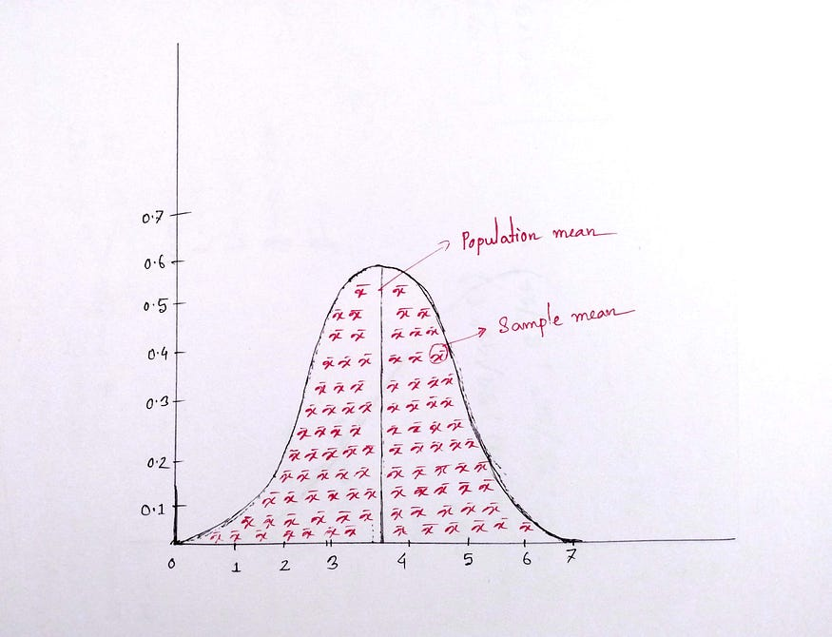

Estimator and Estimate
Estimators are the terms of statistics by which we estimate some facts about the population. Some estimators are the sample mean, standard deviation, variance, etc.
The value of the estimator is known as the estimate.
Suppose the variance of a sample is 5. Here, the variance is the estimator, and the value of the variance is called the estimate.

Standard Error
Standard deviation indicates how far the values are from the population mean, and standard error shows how far sample means are from the population mean. It is calculated as follows —
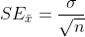
Here, σ is the population standard deviation, and n is the sample size.

Confidence Level and Interval
- Confidence Level
The confidence level is the percentage value; within that value the parameter’s truth value will remain. Suppose we have solved a problem with a 95% confidence level; that means 95% time, we will get the accurate result from our solved problem.
- Confidence interval
The confidence interval is a range within which we will get the truth value of the confidence level.

Significance Level
The significance level of an event (such as a statistical test) is the probability that the event could have occurred by chance. If the level is quite low, that is, the probability of occurring by chance is quite small, we say the event is significant.
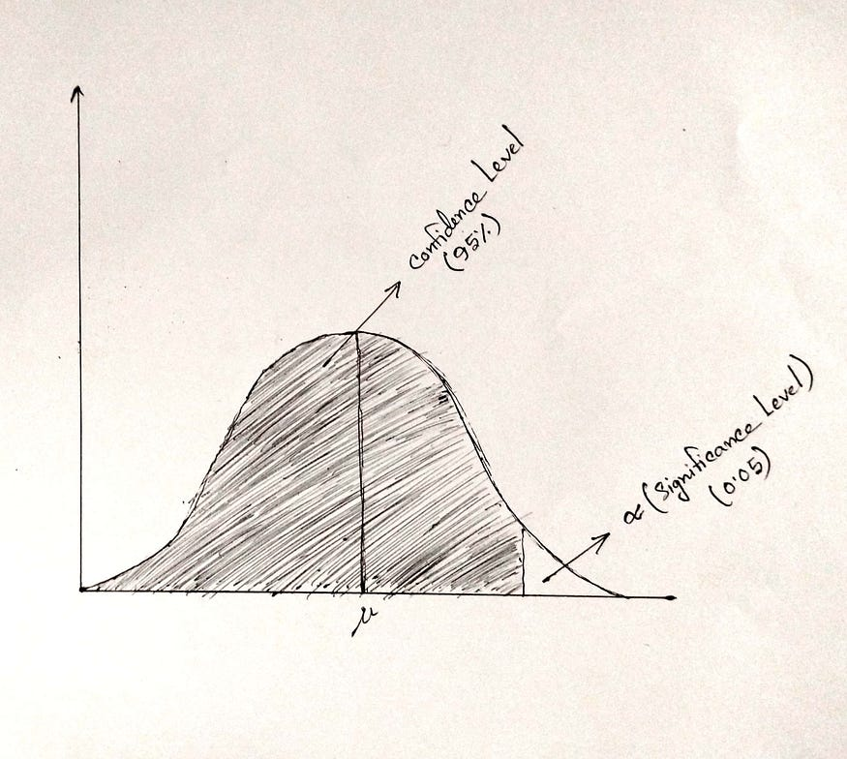
(Significance Level)
Significance level is denoted by α symbol.

Hypothesis Testing
Hypothesis testing is a statistical technique by which we can test and validate an assumption. In hypothesis testing, we consider a null hypothesis, which is assumed to be true, and an alternative hypothesis, which is acceptable if the null hypothesis fails.
State the null hypothesis (H0): The null hypothesis is the default assumption or claim about the population that is typically formulated as a statement of no effect, no difference, or no relationship. It represents the status quo or the absence of any change.
State the alternative hypothesis (Ha or H1): The alternative hypothesis is the claim that contradicts the null hypothesis. It represents the researcher's belief or the alternative explanation being tested.
Set the significance level (α): The significance level, often denoted as α (alpha), determines the threshold for rejecting the null hypothesis. It represents the maximum tolerable probability of making a Type I error, which is the incorrect rejection of the null hypothesis when it is true. Commonly used significance levels are 0.05 (5%) and 0.01 (1%).
Collect and analyse the data: Data is collected through observation or experimentation. Descriptive statistics and inferential statistical methods are applied to summarize and analyze the data, respectively.
Determine the test statistic: The choice of the test statistic depends on the nature of the data and the research question. Common test statistics include t-tests, chi-square tests, ANOVA, correlation coefficients, and regression coefficients.
Calculate the p-value: The p-value is the probability of obtaining a test statistic as extreme as or more extreme than the observed value, assuming that the null hypothesis is true. It measures the strength of the evidence against the null hypothesis. A smaller p-value indicates stronger evidence against the null hypothesis.
Compare the p-value to the significance level: If the p-value is less than the significance level (p-value < α), the evidence is considered statistically significant, and the null hypothesis is rejected in favor of the alternative hypothesis. If the p-value is greater than or equal to the significance level (p-value ≥ α), there is not enough evidence to reject the null hypothesis.
Draw conclusions: Based on the results, conclusions are made regarding the research question. If the null hypothesis is rejected, it suggests that there is sufficient evidence to support the alternative hypothesis. If the null hypothesis is not rejected, it indicates that the data does not provide enough evidence to conclude in favor of the alternative hypothesis.

Analysis of Variance (ANOVA)

ANOVA (Analysis of Variance) is a statistical hypothesis testing method used to determine whether there are any significant differences between the means of two or more groups.
Here are the key steps involved in performing an ANOVA hypothesis test:
- Formulate Hypotheses: The first step in ANOVA hypothesis testing is to formulate the null and alternative hypotheses. The null hypothesis (H0) is that there is no significant difference between the means of the groups, while the alternative hypothesis (Ha) is that there is a significant difference.
- Choose the Level of Significance: The level of significance (α) is the probability of making a Type I error (rejecting a true null hypothesis). It is typically set at 0.05.
- Collect Data: Data is collected from each group, and the mean and variance of each group are calculated.
- Calculate the Test Statistic: The test statistic is calculated by comparing the variability between the groups to the variability within the groups. This is done by calculating the F-statistic, which is the ratio of the between-group variance to the within-group variance.
- Determine the Critical Value: The critical value is the value of F that separates the rejection region (where we reject the null hypothesis) from the non-rejection region (where we fail to reject the null hypothesis). This is determined by looking up the F-distribution table or using a statistical software package.
- Make a Decision: Compare the calculated F-value to the critical value. If the calculated F-value is greater than the critical value, then we reject the null hypothesis and conclude that there is a significant difference between the means of the groups. If the calculated F-value is less than the critical value, we fail to reject the null hypothesis.
- Interpret Results: Finally, we interpret the results and draw conclusions based on our findings.

Advantages of ANOVA:
- ANOVA can handle multiple groups and variables simultaneously.
- It allows us to test whether the differences between groups are statistically significant or due to chance.
- It provides information about the variability within and between groups.
Disadvantages of ANOVA:
- ANOVA assumes that the data are normally distributed and that the variances are equal across groups. Violations of these assumptions can lead to incorrect results.
- ANOVA does not identify which specific groups differ from each other. Post-hoc tests are often required to identify these differences.
- ANOVA does not provide information about the strength of the relationship between the independent and dependent variables.

The ANOVA(one way Anova specifically here) test in statistics is used to determine whether there are any statistically significant differences between the means of three or more independent (unrelated) groups and draw a conclusion based on that for any test.
An ANOVA test is a way to find out if survey or experiment results are significant.
Lets try to understand ANOVA by setting our Null Hypothesis and Alternate Hypothesis
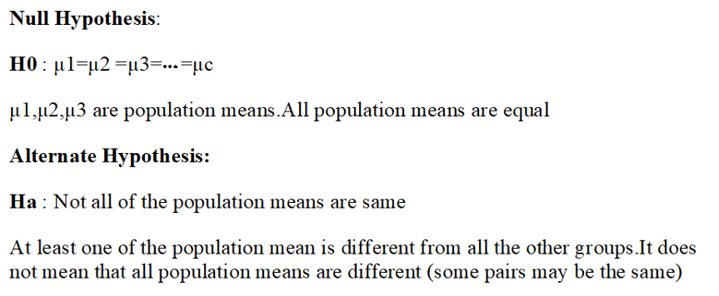

In statistics, the null hypothesis (H₀) and alternative hypothesis (H₁ or Ha) are two competing statements used in hypothesis testing to make conclusions about a population or data based on sample information. They represent different assertions or claims about a population parameter or the relationship between variables.

Null Hypothesis (H₀):

The null hypothesis is the default or initial assumption that there is no significant difference, relationship, or effect in the population.

It represents the status quo or the absence of any interesting or meaningful effect.

It is often denoted as H₀ and is formulated in a way that can be tested statistically.

For example, if we are comparing the means of two groups, the null hypothesis might state that there is no difference in means between the groups.

Alternative Hypothesis (H₁ or Ha):

The alternative hypothesis is the statement that contradicts or challenges the null hypothesis.

It proposes that there is a significant difference, relationship, or effect in the population.

The alternative hypothesis can take different forms depending on the research question and the nature of the analysis.

It is denoted as H₁ or Ha and is often what the researcher is trying to support or find evidence for.

Using the example of comparing means, the alternative hypothesis could state that there is a significant difference in means between the groups.

The purpose of hypothesis testing is to assess the evidence from the sample data and determine whether there is enough statistical evidence to reject the null hypothesis in favour of the alternative hypothesis. This decision is based on the strength of the evidence and the chosen level of significance (alpha).

The process of hypothesis testing involves selecting an appropriate statistical test, collecting sample data, calculating test statistics, and comparing them to critical values or p-values to make a decision.

It's important to note that failing to reject the null hypothesis does not prove it to be true; it simply means that there is insufficient evidence to support the alternative hypothesis. On the other hand, rejecting the null hypothesis suggests that there is evidence in favour of the alternative hypothesis, but it does not prove it to be true either. Hypothesis testing provides a framework for making informed conclusions based on statistical evidence and helps researchers draw meaningful insights from their data.

Steps to calculate ANOVA :
Let’s say we want to know if number of books read by each group is same or not where each group has three student.
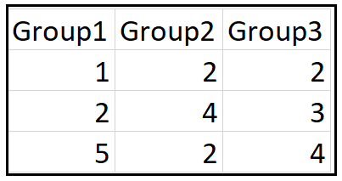
Step 1 : Find the Grand Mean
Its two step Process :
A. Find the sum of each group divided by total number of values in each group.
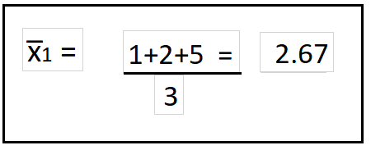
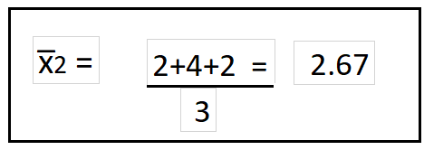
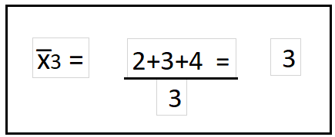
B. Add all the groups sum and divide them by number of groups to get the Grand Mean.
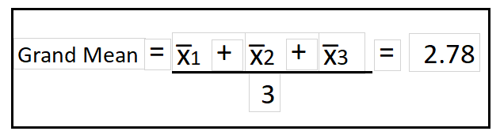
Step 2:Calculate DOF(Degree of Freedom) between groups and within groups.
DOF(Between) : K-1 = 3–1 =2
Where K is number of groups
DOF(Within) : N-K =9–3 =6
Where N is total Number of values considering all the groups
Step 3: Find F(Critical) value to compare. Check below F-Distribution table
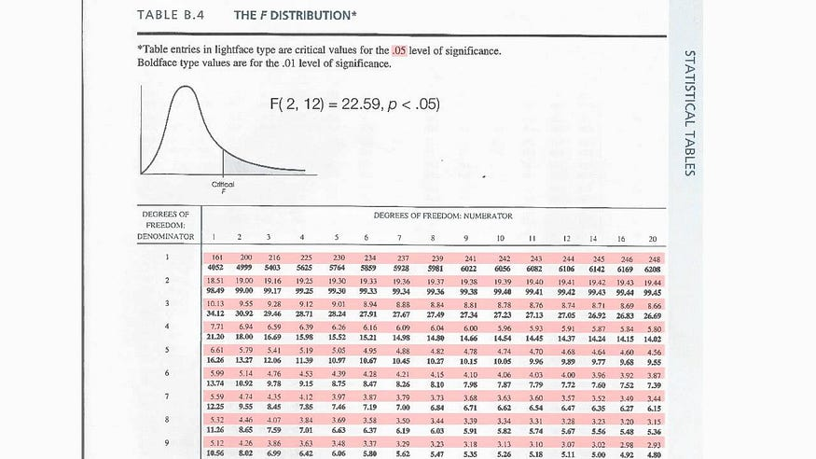
Significance Level considered here is 0.05
F(Critical) =F(DOF(Between), DOF(Within)) =5.14
Step 4 : Find Sum of Squared total(SStotal)
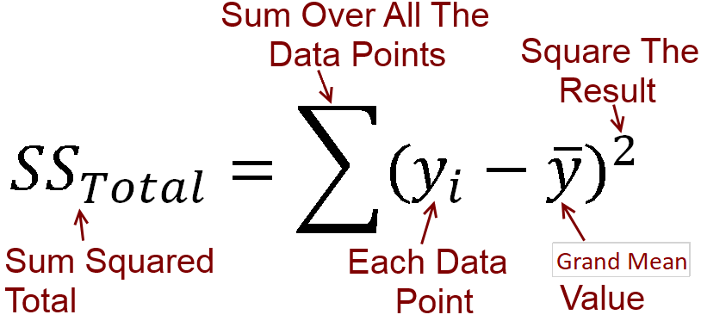
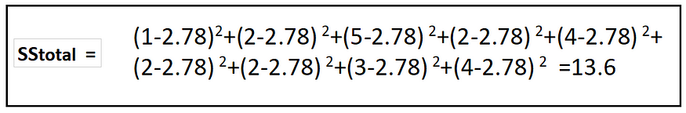
Step 5 : Find the Sum of Squared within(SSw) groups
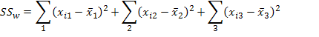
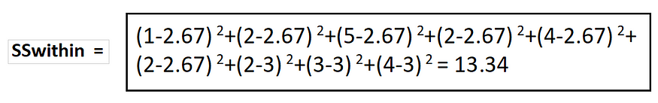
Step 6: Find the Sum of Squared between (SSb) groups

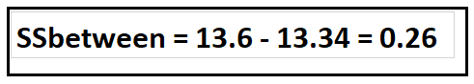
Step 7 : Mean Squared/ Variance between groups & Mean Squared/ Variance within groups
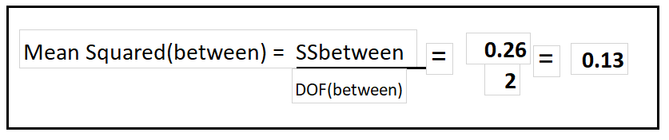
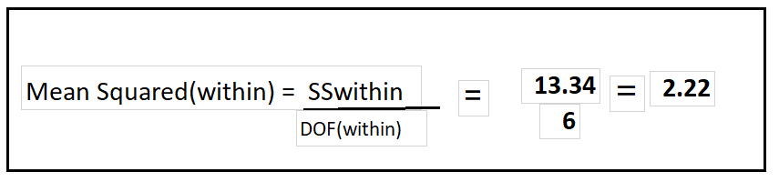
Step 8 : Find the F-Statistics value
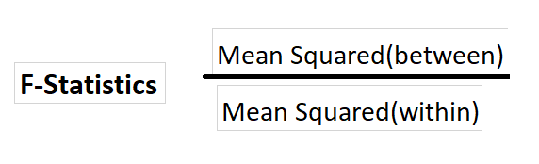
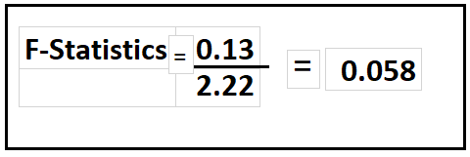
F(Critical) calculated in Step 2 is 5.14

F-Statistics< F(Critical) = 0.058 < 5.14
If F-Statistics is less then F(Critical) which is the case here,We fail to Reject Null Hypothesis.It mean all means are same.(Each groups read same numbers of book)
H0 : μ1=μ2 =μ3=⋯=μc
Conclusion : ANOVA is very important concept in statistics and used frequently in data science domain to verify the means of tests/experiments.

Hypothesis Testing — Analysis of Variance (ANOVA)
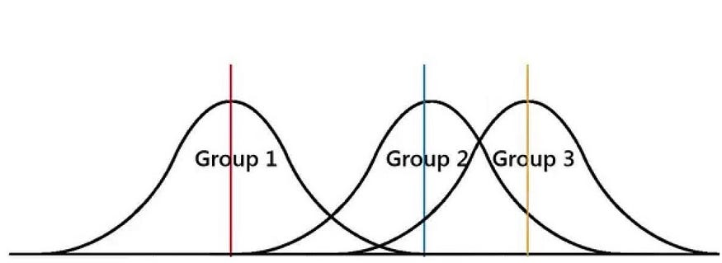

Introduction:
ANOVA (Analysis of Variance) provides a statistical test of whether two or more population means are equal. Assume we want to determine whether multiple groups differ from one another in a measurement. For example, lets say we want to determine whether the amount of uber riders differs by season in New York City. You could use t-test to determine this, but that would require you to use 6 tests (n(n-1)/2). The more tests you conduct, the bigger the risk is that you come to a false conclusion. To counteract this issue, you can use an ANOVA test. Instead of looking at each individual difference, ANOVA examines the ratio of variance between groups and the variance within groups to determine whether the ratio is big enough to be statistically significant.
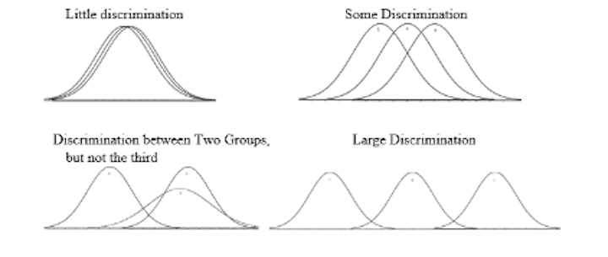

Types of ANOVA Tests:

ANOVA (Analysis of Variance) is a statistical technique used to compare the means of two or more groups to determine if there are any significant differences between them. There are several types of ANOVA tests, each suited for different experimental designs and research questions. Here are the main types of ANOVA tests:

One-Way ANOVA: This is the most basic form of ANOVA, used when there is one independent variable with more than two levels or groups. It compares the means of these groups to determine if there are any significant differences. For example, comparing the effectiveness of three different treatments on a specific outcome.

Two-Way ANOVA: In Two-Way ANOVA, there are two independent variables or factors, each with multiple levels. It examines the effects of these two factors on the dependent variable and their interaction. For example, studying the influence of both gender and age on a test score.

Factorial ANOVA: Factorial ANOVA extends the concept of Two-Way ANOVA to include more than two independent variables or factors. It allows for the examination of the main effects of each factor, as well as their interactions. For example, investigating the effects of gender, age, and education level on job satisfaction.

Repeated Measures ANOVA: This type of ANOVA is used when measurements are taken on the same individuals or subjects over multiple time points or conditions. It analyzes the within-subjects or within-groups differences. For example, assessing the effect of a drug on blood pressure at various time intervals.

Mixed ANOVA: Mixed ANOVA combines between-subjects and within-subjects factors. It is used when there are both independent groups and repeated measures in the same study. For example, examining the effect of a training program (independent groups) and time (repeated measures) on athletic performance.

MANOVA (Multivariate Analysis of Variance): MANOVA extends ANOVA to situations where there are multiple dependent variables. It simultaneously analyzes multiple dependent variables to assess differences between groups. For example, comparing the effects of different teaching methods on students' academic performance across multiple subjects.

ANCOVA (Analysis of Covariance): ANCOVA combines ANOVA with regression analysis to control for the effects of one or more covariates. It is used when there are variables that may have a confounding influence on the relationship between the independent variable(s) and the dependent variable. For example, examining the effect of a new teaching method on test scores while controlling for students' IQ.

Each type of ANOVA test has its own assumptions and considerations. It is important to carefully select the appropriate ANOVA test based on the research design, the nature of the variables, and the specific research question being investigated.

Calculating ANOVA:
For ANOVA tests, we would set up a null and alternative hypothesis like so:
Hnull → µ1 = µ2 = µ3 = µ4
Halternative → Hnull is not true.
To calculate ANOVA, you would use the following formulas:
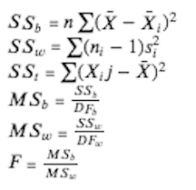
Degrees of Freedom for ANOVA:
- DF between = k -1
- DF within = N-k
- DF total = N-1
Key:
- k = number of groups
- N = total number of observations
- n = number of observations for each group
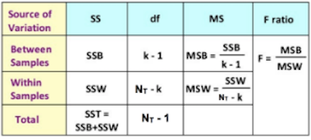

Limitations of the one-way ANOVA:
A one-way ANOVA will help you determine whether the two or more groups are difference from each other, but it will not be able to tell you which specific groups were different from one another. In this case, you should run an ad-hoc test to determine which groups had different means.

Assumptions for the two-way ANOVA and three-way ANOVA:
- The population is close to normal distribution
- The sample are independent
- Population variances are equal
- Groups have equal sample sizes

Chi-Square Test
The Chi-Square test is another statistical test for finding the dependency of categorical variables.

What is a Chi-Squared test?
The chi-squared test is a way to check if something fits a specific probability distribution. It’s often used to determine whether the difference between two populations is large enough that it could have happened by chance alone. This means you can use chi-squared to find out if things follow certain probability distributions like a normal distribution or an exponential distribution or to check if the difference between two groups is large enough it could happen just by chance.
A chi-squared test is used to determine whether a particular trend could be attributed to random chance or if there was something systematic causing the trend. For example, let’s say you’ve noticed that 80% of your sales are coming from only 2 out of 50 of your widgets. You might wonder if it is because of something systematic with those 2 widgets.
Perhaps they are higher quality, priced lower, or maybe those are the only ones that have been featured on a popular blog. To see if that is the case, you would run a chi-squared test on the data to see if it confirms your hypothesis, or shows no significant difference between the different groups.

Information about Chi-Squared and how it is used?
Chi-Squared is an extremely useful concept to understand in the world of statistics. I know it can be a little challenging to wrap your mind around in the beginning, but just think about it like this: if you didn’t have Chi-Squared and other hypothesis tests, you wouldn’t be able to conclude whether two data sets were significantly different. You wouldn’t be able to compare two diets or two weight loss methods you wouldn’t even be able to tell if there was a significant difference between treatments for a drug after conducting a clinical trial.

When should I perform a chi-squared test?
A chi-squared test can be used when you have categorical data and want to see if there is a significant relationship or association between one or more variables. The most common use of chi-squared tests in marketing research is in 2 x 2 contingency tables comparing the results of two groups on some variable (respondents with different attitudes, respondents exposed to different ads, etc.).
There are two main uses for chi-squared tests:
1. To test if an expected frequency is above or below the expected value. This can be used to identify anomalies in a data set, such as inconsistencies in information provided by different sources of data.
2. To compare two sets of data and determine which has a higher degree of variation, based on the given measure of variation within each set of data.

How to Calculate Chisquare?
Chi-squared tests determine if an observed phenomenon has a non-random probability of occurring. An example of this would be to test in a survey if the answers are truly independent or not. The formula is used to calculate the relationship between the observed and expected results. It’s typically used in quality assurance, but it’s also useful to understand while studying statistics.
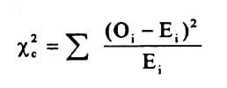

What are the parameters for a Chi-Squared test?
The Chi-Squared test is used to determine whether a given data set has a significant probability of coming from the population or not. This is done by comparing the data set against the expected distribution for that population. If there is a high enough disparity, then this indicates that the data set does not come from that population and warrants further investigation.

How to perform a chi-squared test on your data?
If you’re performing a Chi-Squared test, we can help. A Chi-Squared distribution is similar to a normal distribution, except it is skewed to the right. The number of degrees of freedom will determine how wide or narrow your final graph appears.
A chi-squared test is an inferential statistic used to determine if the observed data fit with a certain expected probability distribution. For example, you can use a chi-squared test to determine if the number of heads in 100 coin tosses is statistically greater than or less than 50 heads. Sample size calculations are done using the chi-squared distribution as well as other distributions.

